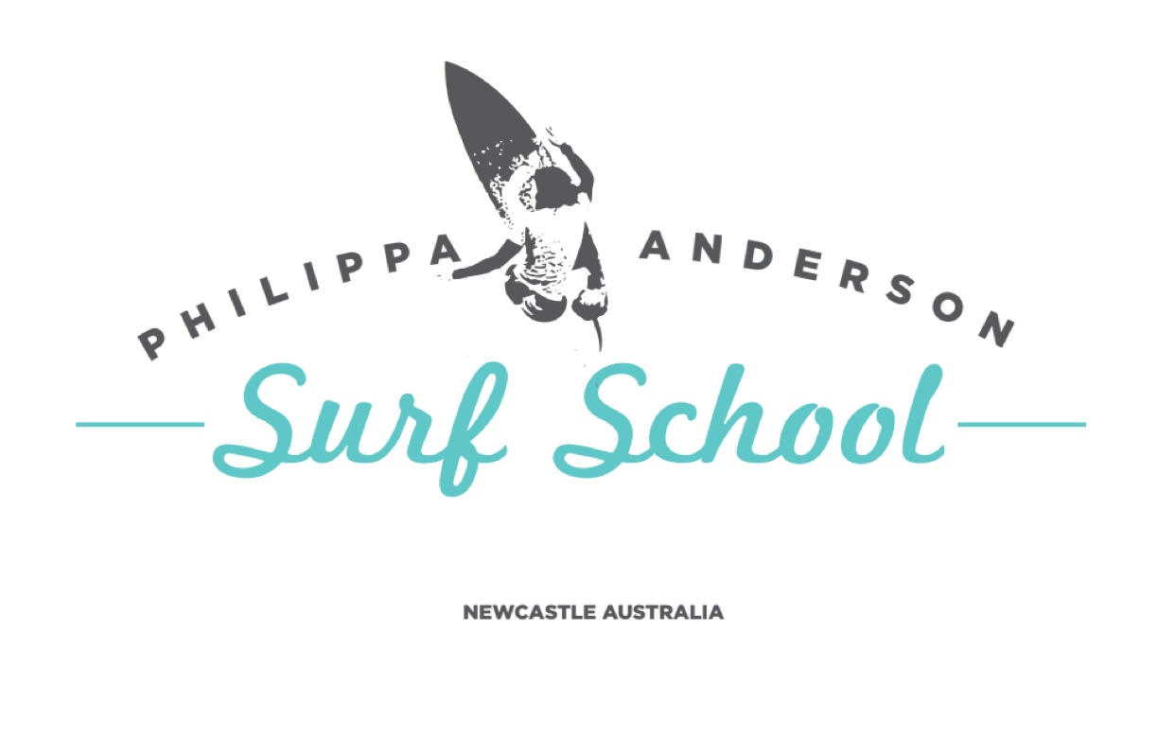
INDEMNITY FORM

In consideration of Organisers accepting my application to participate in surf lessons below, I acknowledge, understand and agree that:

1. “Organisers” for the purpose of this declaration means the Philippa Anderson Surf School and includes, where the context so permits, Surfing Australia Inc (“SA”), SA affiliated state surfing associations and their respective directors, officers, members, servants or agents.  2. Warning: Participating in lessons can be inherently dangerous. I understand the nature and requirements of the lesson and acknowledge that serious accidents can and often do happen which may result in me being seriously injured or even killed. I have voluntarily read and understood this warning and accept and assume the inherent risks in participating in the lesson.  3. Physical Fitness: I must not participate in lessons if I have  any injuries, disability, medical or health conditions that may increase the risk of me becoming injured unless I have informed the Philippa Anderson Surf School about it and they have authorised me to participate. I declare that I am medically and physically fit and able to participate in lessons and I will immediately notify an instructor of any change to my fitness and ability to participate. I understand and accept that Philippa Anderson Surf School will continue to rely on this declaration as evidence of my fitness and ability to participate.  4. Instructions: I will at all times comply with the instructions and safety procedures at Philippa Anderson Surf.  5. Medical Treatment: If required, Philippa Anderson Surf School will arrange medical or hospital treatment (including ambulance transportation) for me. I authorise such actions being taken by Philippa Anderson Surf School and agree to meet all costs associated with such action. | 6. Release & Indemnity: My participation in the lesson is entirely at my own risk and I agree to:  (a) Release and forever discharge Philippa Anderson Surf School from all Liability and Claims that I may have or may have had but for this release arising from or in connection with my participation in the lesson.  (b) Indemnify and hold harmless Philippa Anderson Surf School to the extent permitted by law in respect of any Claim by any person including but not only another participant in the lesson arising as a result of or in connection with my participation in the lesson.  In this clause 6 “Claims” means and includes any action, suit, proceeding, claim, demand, penalty, cost or expense however arising (including negligence, trespass to the person), other than claims as a result of a breach of consumer guarantees Under Australian Consumer Law.”  7. Identity: Photographic and or visual images taken by Philippa Anderson Surf School of my participation in lessons may be used for general promotion at Philippa Anderson Surf School.  8. Privacy: I understand that the information provided by me in this form is necessary for the operation of the lesson. I acknowledge and agree that the information will only be used for the objects at Philippa Anderson Surf School and to provide me with information pertaining to the lessons and Philippa Anderson Surf School activities. I understand that I will be able to access my information through Philippa Anderson Surf School upon request. If the information is not provided I might not be permitted to participate in the Program.
I have read, understood, acknowledge and agree to the above declaration including the warning, release and indemnity.
Name: ________________________________________________________________________
Surfer’s Medical Information (confidential) - please indicate any medical conditions that coaches should be aware of: ____________________________________________________________________________________________________________________________________________________________________
Signed: ________________________________________________________
Where the applicant is under 18 years of age this form must also be signed by the applicant’s parent or legal guardian.
I, (please print name)_______________________________________________________ am the parent or guardian of the applicant. I expressly agree to be responsible for the applicant’s behaviour and agree to personally accept the conditions set out in this application and declaration including the provision by me of a release and indemnity in the terms set out above.
Parent/Guardian’s signature (where applicant is under 18 years old):
______________________________________________________ Date: ______________________

Philippa Anderson Surf School
Email: info@philippaandersonsurfschool.com.au
Mobile: 0492 972 234
ABN 50 641 329 651

